Setting up a Zoho Creator Account and Exploring The Platform Architecture and Interface
SUPRIYA.T.R
241401111 B.Tech CSBS

Introduction
This report documents a hands-on experience of setting up a Zoho Creator account and exploring its core platform architecture and interface. Zoho Creator is a low-code application development platform that enables users to design custom business applications through a combination of drag-and-drop tools (Forms, Reports, and Pages) and optional scripting (Deluge) for advanced automation. The screenshots below were captured during the walkthrough and are presented in the order they were encountered, each accompanied by a description of what the screen shows and how it fits into the overall Creator architecture.
Together, these steps illustrate the platform's layered design: data capture (Forms), data presentation (Reports and Pages), business logic (Workflows/Deluge), and access governance (Permissions) — all managed from a single, unified builder interface.

Zoho Creator Platform Architecture
Before walking through the interface step by step, it helps to see how Zoho Creator is structured underneath. The platform is organized into distinct layers that work together to take an application from user access all the way to deployment. The diagram below summarizes this layered architecture, based on the modules encountered during account setup and exploration.
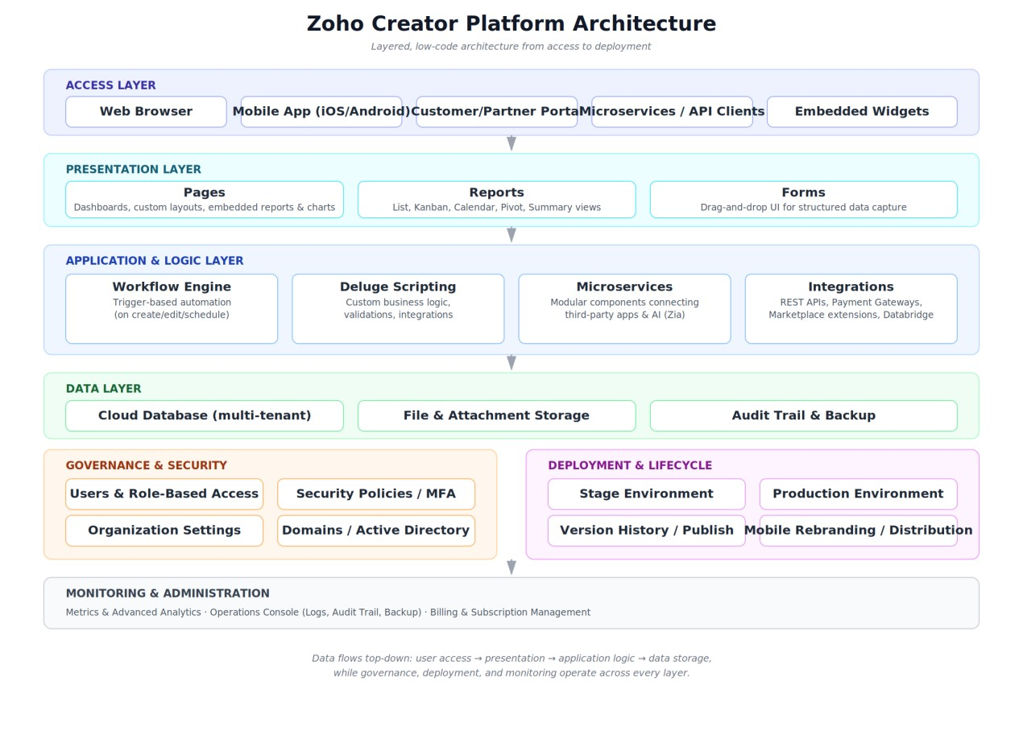
Figure 0: Zoho Creator platform architecture, from access to deployment
At the top, the Access Layer covers every way users reach an app — browser, mobile app,
customer/partner portal, or API/microservice calls. Beneath that, the Presentation Layer (Pages, Reports, Forms) is what users actually see and interact with. The Application & Logic Layer is where the platform's low-code power lives: a Workflow Engine and Deluge scripting handle automation and validation, while Microservices and Integrations connect the app to third-party services, payment gateways, and AI (Zia). All of this reads from and writes to the Data Layer — the cloud database, file storage, and audit/backup systems.
Running alongside these layers are two cross-cutting concerns visible throughout the platform: Governance & Security (users, roles, security policies, domains) and Deployment & Lifecycle (Stage and Production environments, version history, and mobile app distribution). A final Monitoring & Administration layer — Metrics, Operations, and Billing — gives account owners visibility and control over the whole system. The screenshots that follow trace this architecture in action, starting from account setup and moving through each of these layers in turn.

Step 1: Accessing the Zoho Creator Sign-Up / Sign-In Page
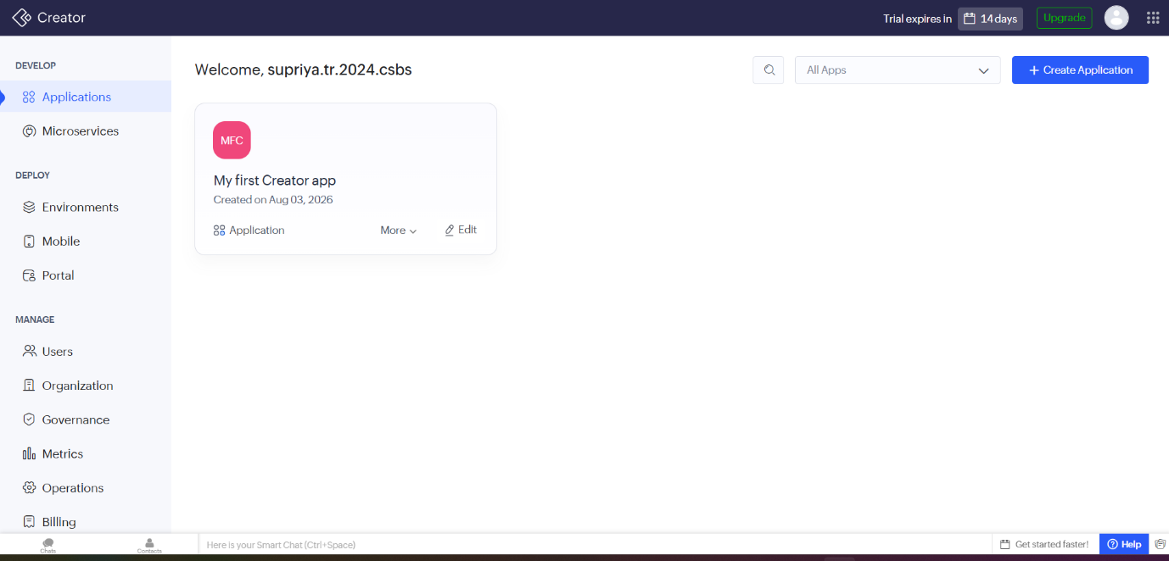
Figure 1: Accessing the Zoho Creator Sign-Up / Sign-In Page
The experiment begins at Zoho Creator's entry page, where a new user is prompted to sign in or create a
Zoho account. This is the gateway to the platform, requiring a valid email address (or an existing Zoho/Google/social account) to proceed. This first screen establishes account authentication before any application-building features become accessible.

Step 2: Landing on the Zoho Creator Home Dashboard
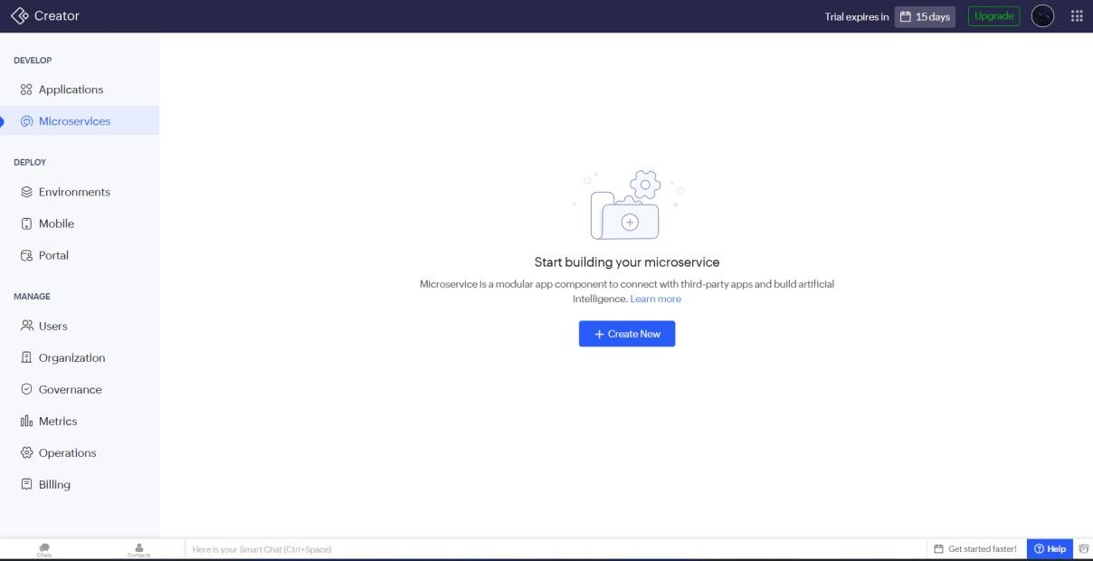
Figure 2: Landing on the Zoho Creator Home Dashboard
After signing in, the user is taken to the Zoho Creator home dashboard. This central hub lists all applications associated with the account and provides quick-access options to build a new app — either from scratch, from a template, or by importing existing data. The dashboard reflects the platform's lowcode philosophy: application management and creation are consolidated in a single, uncluttered view.

Step 3: Creating a New Application
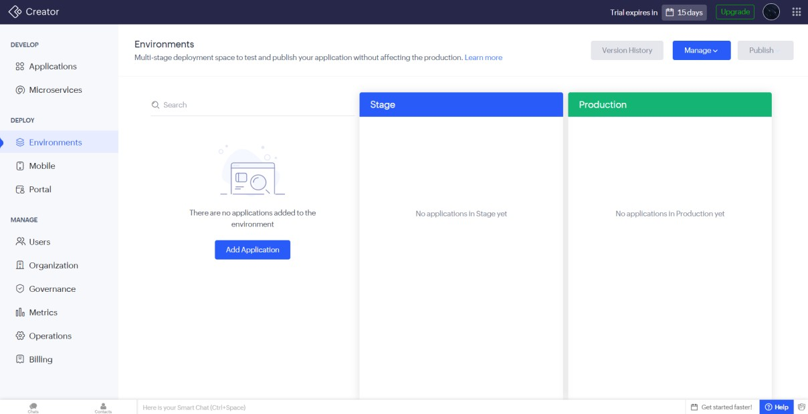
Figure 3: Creating a New Application
This screen captures the 'Create Application' step, where Zoho Creator offers multiple starting points — building an app from a blank canvas, choosing a pre-built template from the marketplace, or importing a
spreadsheet/file to auto-generate the initial structure. This flexibility is a core part of Creator's architecture, letting users of varying technical skill levels start at the point that suits them best.

Step 4: The Application Builder Workspace
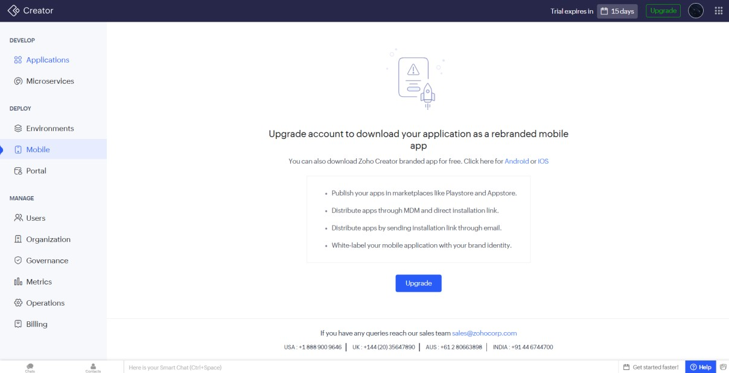
Figure 4: The Application Builder Workspace
Once an application is created, the main builder workspace opens. The interface is organized around a left-hand navigation panel listing the core building blocks of a Creator app — Forms, Reports, Pages, and Workflows — while the central canvas area is used to design and preview each component. This layout reflects Zoho Creator's underlying architecture, where an application is essentially a collection of linked forms, reports, and automation logic.

Step 5: Exploring the Form Builder and Field Palette
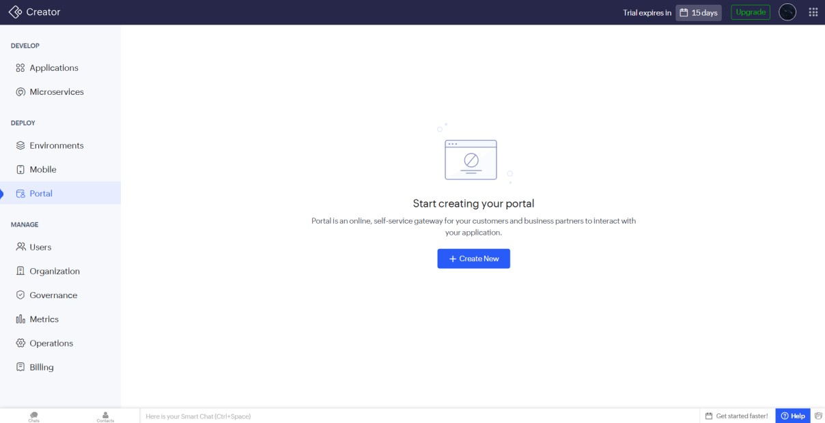
Figure 5: Exploring the Form Builder and Field Palette
This screenshot shows the drag-and-drop Form Builder, the component used to define how data is captured. A palette of field types (text, number, dropdown, date, file upload, and similar controls) sits alongside the design canvas, allowing fields to be dragged directly onto the form. This visual, no-code approach to schema design is central to how Zoho Creator abstracts away database table creation from the end user.

Step 6: Configuring Form Fields and Properties
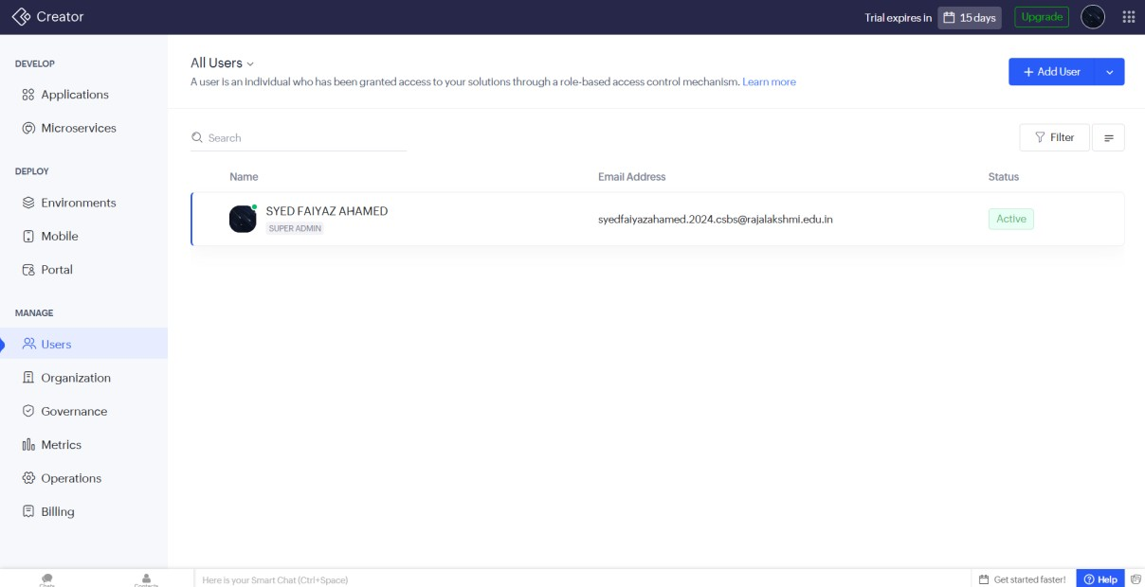
Figure 6: Configuring Form Fields and Properties
Here, a field has been selected on the form canvas, opening its properties panel. From this panel, attributes such as field label, data type, validation rules, default values, and mandatory/optional status can be configured. This demonstrates how Zoho Creator lets non-developers define fairly sophisticated data-validation logic purely through configuration, rather than code.

Step 7: Working with Reports
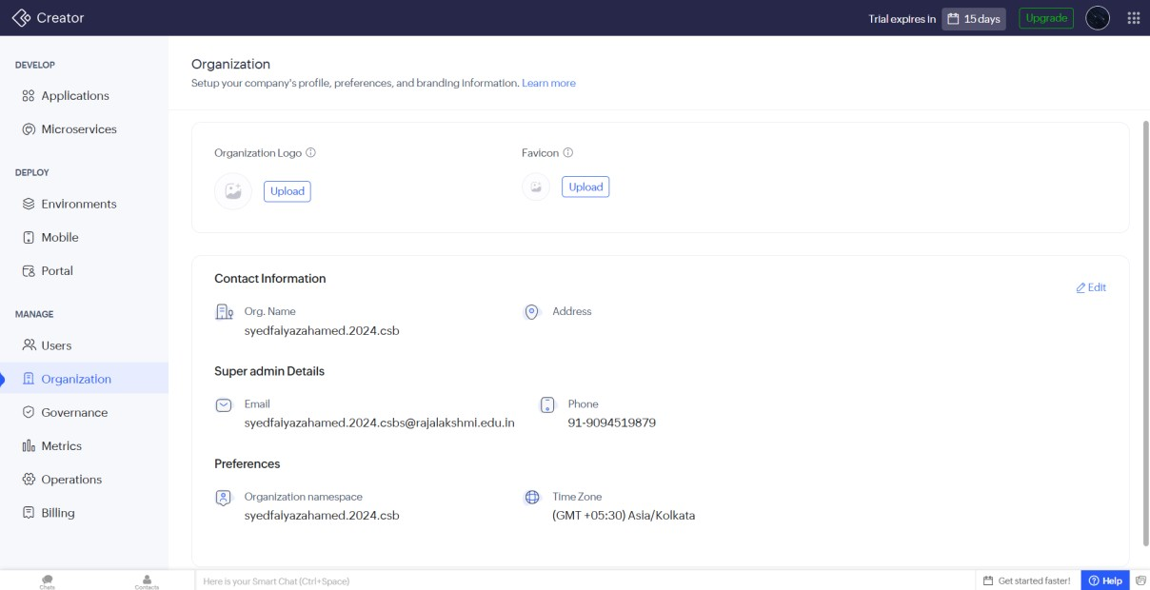
Figure 7: Working with Reports
This screen highlights the Reports section of the platform, where submitted form data can be viewed and organized in different formats — such as list views, Kanban boards, calendars, or pivot tables. Reports are auto-generated from the underlying form and can be filtered, sorted, and customized, illustrating how Creator separates data capture (Forms) from data presentation (Reports).

Step 8: Automation with Deluge Scripting
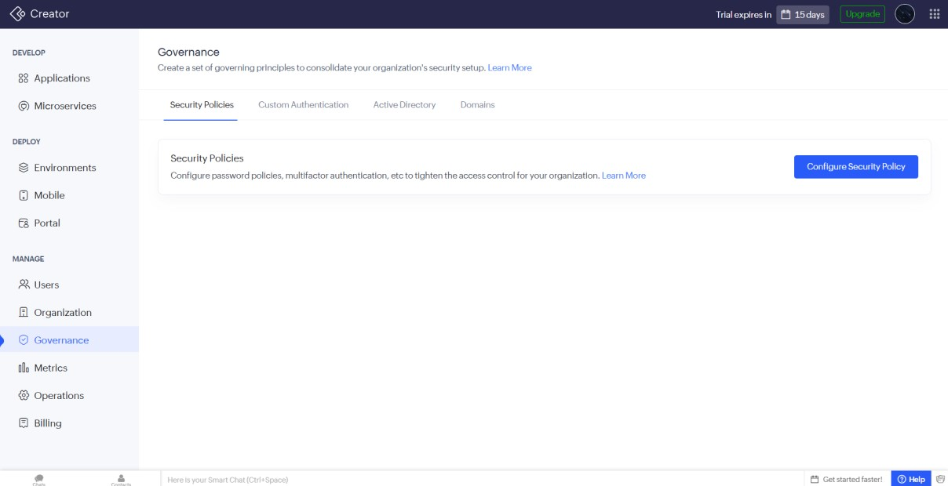
Figure 8: Automation with Deluge Scripting
This screenshot captures the Deluge script editor, Zoho Creator's proprietary scripting language used to build custom workflows, business logic, and automations (for example, sending notifications or updating related records on form submission). The presence of a dedicated scripting environment shows that, beyond drag-and-drop configuration, Creator also supports code-level customization for more advanced use cases.

Step 9: Designing Pages and Dashboards
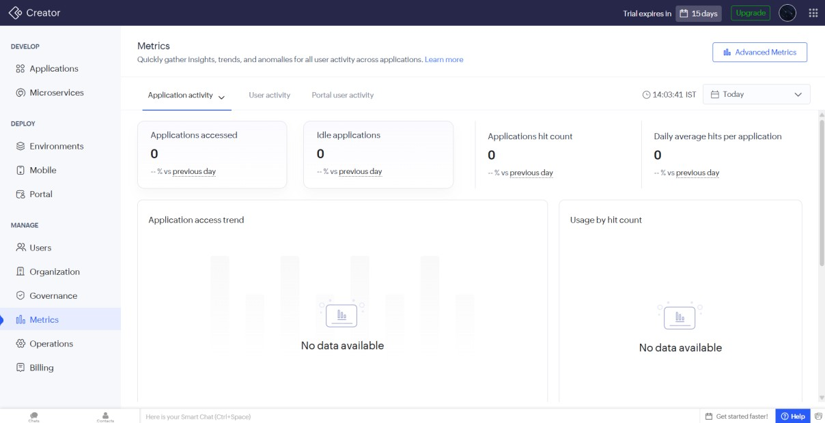
Figure 9: Designing Pages and Dashboards
This view shows the Pages module, used to build custom dashboards and landing screens by combining reports, charts, and widgets into a single layout. Pages act as the presentation layer of an application, letting the builder curate what end users see when they open the app, separate from the raw forms and reports underneath.

Step 10: Managing Permissions and User Roles
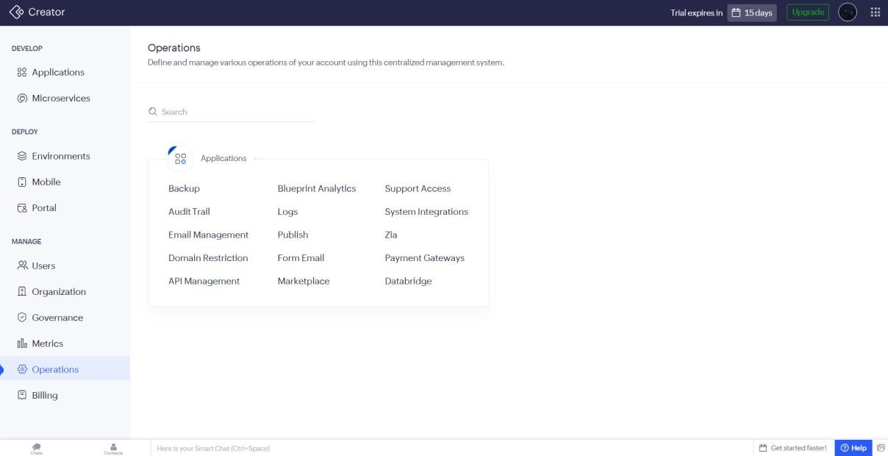
Figure 10: Managing Permissions and User Roles
This screenshot shows the permissions/roles configuration area, where access to forms, reports, and specific fields can be restricted by user role. This reflects an important architectural layer of Zoho Creator — security and access control are managed centrally and can be applied granularly across every component of the app.

Step 11: Previewing and Publishing the Application
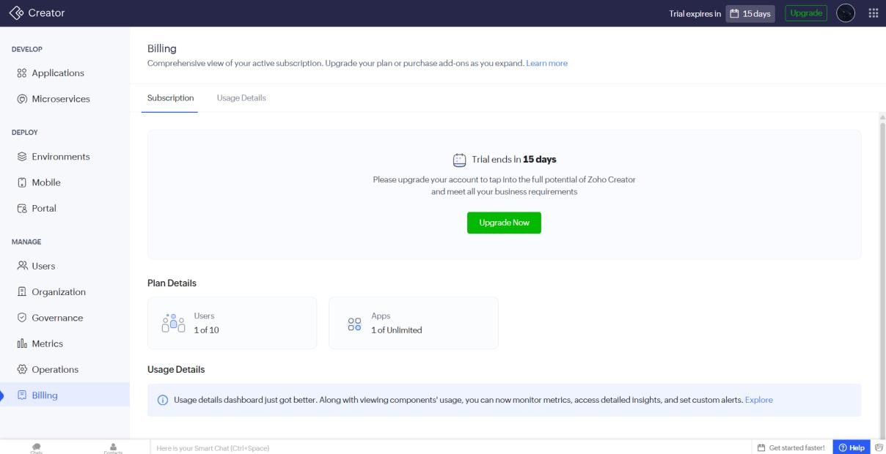
Figure 11: Previewing and Publishing the Application
The final screenshot shows the built application in preview/live mode, as an end user would see it after publishing. This confirms the full loop of the platform's architecture: a form for data entry, reports/pages for viewing that data, workflows for automation, and permissions for access control, all combined into one deployable business application.

Conclusion
This walkthrough of setting up a Zoho Creator account offered a clear view into how the platform structures application development. The account setup and app-creation flow are simple and guided, while the builder interface reveals a well-organized architecture built around four pillars: Forms for data entry, Reports and Pages for data presentation, Deluge scripting for custom automation, and role-based Permissions for access control. This structure allows both non-technical users and developers to build functional business applications at a pace suited to their skill level, making Zoho Creator a flexible entry point into low-code application development.

